dplyr and the Star Wars dataset

When you load dplyr into R, there is a database which is automatically loaded based on the Star Wars universe. It has information about different creatures such as hair color, weight, home planet etc. To access the Star Wars database, you first must download the dplyr library and turn it on. I would suggest downloading Tidyverse and using it instead. Tidyverse is a compilation library which contains dplyr and several other useful libraries created by Hadley Wickham. https://www.tidyverse.org/
install.packages(“tidyverse")
library(tidyverse)

- Create a data.frame called droids from the starwars dataset, use only species that are droids (Droid column). Use the pipe operator (%>%) and dplyr. How many droids are there?
  - 6

- Create a data.frame with the names of all characters who have blonde hair and blue eyes. Who are the three characters with those features?
  - Luke Skywalker
  - Anakin Skywalker
  - Finis Valorum

- Create a new data.frame called obese. The data.frame will consist of the name, the height of the character, the weight of the character and the bmi of the character. The bmi column will use the following formula:
bmi = mass / ((height / 100) ^ 2)
The obese data.frame contain characters who have a bmi > 30, and it will be arranges in descending order (heaviest to lightest with a bmi>30). Who are the two characters that need to diet the most, and what is their bmi?
  - Jabba
  - Dud Bolt

- Create a data.frame called species, which lists the number of characters for each species (note, in your summarize function, you can use the n=n() for a summary by group. Filter the data frame so only choose species where n > 1. How many humans are there in the data.frame?
  - 35
- What is the average mass of each species? (Hint add ave_mass = mean(mass) to your summarize function. Arrange by n first then ave_mass both in descending order. What species has the highest mass?
  - Wookiee
- How many females and males are in the dataset? What is their average, max and min heights, and weights?
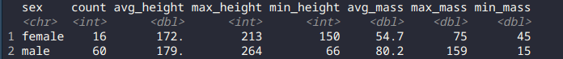

- Combine the name and species columns to create a new column called “name_species” using the unite() command.
  - I got an error saying it could not find a unite command
- Create a new data.frame called oldest, and list the name of the character, homeland and the age of the character in descending order.
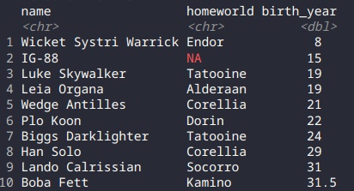

Looping Questions (put your code in the answers)

- Create a for loop which takes a sequence of numbers from 1-10 and squares them. Please list your code.
  - For (x in 1:10) {
print(x^2)
}

- Create a nested for loop which prints out a list of the dates from April until today’s date. The printout should be “4-1-2020”,”4-2-2020”, . . . “6-27-2020”, “6-28-2020”
So it would be a for loop which goes from 4-6 for the months and another for loop which goes through the days. Here is a bit of skeleton code you need to create the loops. In order to get this done, you will need the paste0 command. It is a command which pastes test strings together. So for example,
print(paste0(month, “-“, date))
would print the “4-20-2020” if month = 4 and date = 20

for (month in 4:6) {
for(day in 1:30){
print(paste(month,”-”,day,”-2020”))
if (month == 5 & day == 30){
print(“5-31-2020”)
}
}

Function Questions (put your code in the answers)
- Create a function which returns the fourth power of the number given. So forth_power(10) would return the number 10000, fourth_power(2) would return 16
fourth_power = function(x) {
x^4
}
- Create a function which returns a Fibonacci sequence’s term for the given number. So for example, fib(10) would return the 10th item in the Fibonacci sequence. This is a very difficult problem because there are two different objects which need to change simultaneously and add together for a result. Expect to take a lot of time with this problem.
#This is a very slow solution, but was the cleanest to type out in a word document
Fib = function(x) {
if (x == 1 | x==0) {
return (1)
}
return(fib(x-1) + fib(x-2))
}

